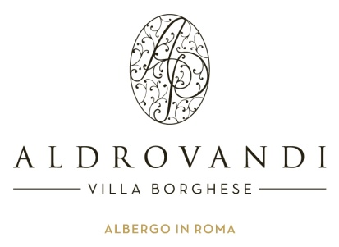
Nomura Global Chemicals Conference 2012

21 – 23 March 2012

Aldrovandi Villa Borghese
Via Ulisse 15 Aldrovandi
00197 Rome, Italy
ACCOMMODATION RESERVATION FORM

Please return this form to the Reservations Department by fax +0039 06 32 21 435, or e-mail your reservation to: Pauline Charles, Executive Conference & Sales at conference2@aldrovandi.com +39 06 32 23 993

IMPORTANT: Please read the following information before completing this form:
- Reservations can only be reserved with a credit card number and valid expiration date.
- The exclusive event rates are available Wednesday 21 March – Sunday 25 March 2012
- Your reservations will be confirmed ONLY when you receive a final confirmation message with the confirmation number from the hotel.
- Check-in time is 2:00 p.m. and check-out time is 12:00 p.m.
- Buffet breakfast included for both single and double accommodation

(please complete all fields with an *)

Last Name* |  | First Name*
Organization |  | Title
Address
Telephone* |  | Fax Number
E-mail*
Arrival Date* |  | Flight/Time
Departure Date* |  | Flight/Time

Room Rate extended to this particular function:

Superior Single Room: € 210.00* per room, per night
Superior Double Room: € 230.00* per room, per night

*The above rate does not include:
- 10% VAT
- City tax Euro 3,00 per person per night

Preferred Room Category: Bed Type Room Type
King-size bed: Non-smoking room:
Two beds: Smoking room:

CANCELLATION POLICY
No penalty will be charged for cancellation received up to 7 days prior to the arrival date.
A one night deposit will be charged for any cancellation received within 7 day of the arrival.
Any no show will be charged for the entire stay.

GUARANTEE Please provide credit card information to secure your reservation:

I hereby authorize the hotel to charge my credit card account for accommodation charges in accordance with the Terms and Conditions stated in this document..

Type of card: _________________________________________
Card number: _________________________________________ Valid until: ___ /______
Card holders name: ____________________________________

Signature: ___________________________________________ Date: ______________

